Problem Statement: University Examination System

Design an Entity-Relationship schema for a university examination system that manages data about exams, students, faculty members, courses, and departments.
Each department has a unique name and is headed by a faculty member. A department can offer multiple courses, and each course has a unique course code, title, and is coordinated by a faculty member.Faculty members have an employee ID, name, and designation. They can teach multiple courses, coordinate specific courses, and also serve as heads of departments. A faculty member may handle multiple roles at once.
Students have a roll number and name, and each student belongs to one department. A student can enroll in multiple courses offered by that department. For each enrolled course, a student has an attendance percentage recorded.
Exams are created by faculty members. Each exam has a title, subject name (which is assumed to be the same as the course name), duration, date, type (internal or external), and is always linked to a specific course. Students may appear in multiple exams related to their courses, and for each exam, a student may have multiple attempts, with marks and attempt dates recorded for each.
All relationships between students, courses, faculty, and exams must reflect these associations clearly such as student-course enrollment, faculty-course teaching, course-department mapping, and exam-course ownership.

ER DIAGRAM:
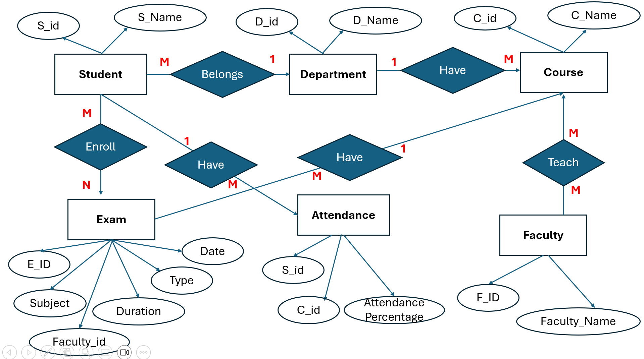

Entities and Attributes:
- Department
  - Attributes: Dept_ID, Name
  - One department has many courses and students.
  - Headed by a faculty member.

- Faculty Member
  - Attributes: Emp_ID, Name, Designation
  - Can coordinate or teach multiple courses.
  - Can head a department.
  - Can create exams.

- Course
  - Attributes: Course_Code, Title
  - Belongs to one department.
  - Coordinated by a faculty member.
  - Taught by faculty members.

- Student
  - Attributes: Roll_No, Name
  - Belongs to one department.
  - Can enroll in many courses.
  - Has attendance per course.

- Exam
  - Attributes: Exam_ID, Title, Subject_Name, Duration, Date, Type (Internal/External)
  - Linked to one course.
  - Created by faculty.
  - Student appears in exams and can have multiple attempts.

- Relationships
  - Department ↔ Faculty (head of department)
  - Department ↔ Course (offers)
  - Faculty ↔ Course (teaches and coordinates)
  - Student ↔ Department (belongs to)
  - Student ↔ Course (enrolls in; has attendance)
  - Exam ↔ Course (based on)
  - Faculty ↔ Exam (creates)
  - Student ↔ Exam (writes; has marks and attempt count)

🧾 SQL Table Creation Statements:

- Department Table:

CREATE TABLE Department (
Dept_ID INT PRIMARY KEY,
Name VARCHAR(100),
Head_EmpID INT,
FOREIGN KEY (Head_EmpID) REFERENCES Faculty(Emp_ID)
);

2.Faculty Table:

CREATE TABLE Faculty (
Emp_ID INT PRIMARY KEY,
Name VARCHAR(100),
Designation VARCHAR(50)
);

3.Course Table:

CREATE TABLE Course (
Course_Code VARCHAR(10) PRIMARY KEY,
Title VARCHAR(100),
Dept_ID INT,
Coordinator_ID INT,
FOREIGN KEY (Dept_ID) REFERENCES Department(Dept_ID),
FOREIGN KEY (Coordinator_ID) REFERENCES Faculty(Emp_ID)
);

4. Student Table:

CREATE TABLE Student (
Roll_No INT PRIMARY KEY,
Name VARCHAR(100),
Dept_ID INT,
FOREIGN KEY (Dept_ID) REFERENCES Department(Dept_ID)
);

5. Enrollment Table:(Student-Course with attendance):

CREATE TABLE Enrollment (
Roll_No INT,
Course_Code VARCHAR(10),
Attendance_Percentage DECIMAL(5,2),
PRIMARY KEY (Roll_No, Course_Code),
FOREIGN KEY (Roll_No) REFERENCES Student(Roll_No),
FOREIGN KEY (Course_Code) REFERENCES Course(Course_Code)
);

6.Course_Teaching (Faculty teaches courses):

CREATE TABLE Course_Teaching (
Emp_ID INT,
Course_Code VARCHAR(10),
PRIMARY KEY (Emp_ID, Course_Code),
FOREIGN KEY (Emp_ID) REFERENCES Faculty(Emp_ID),
FOREIGN KEY (Course_Code) REFERENCES Course(Course_Code)
);

7. Exam Table:

CREATE TABLE Exam (
Exam_ID INT PRIMARY KEY,
Title VARCHAR(100),
Subject_Name VARCHAR(100),
Duration INT,
Date DATE,
Type VARCHAR(20),
Course_Code VARCHAR(10),
Created_By INT,
FOREIGN KEY (Course_Code) REFERENCES Course(Course_Code),
FOREIGN KEY (Created_By) REFERENCES Faculty(Emp_ID)
);

8.Exam_Attempt (Student attempts exams with marks & attempt no.):

CREATE TABLE Exam_Attempt (
Exam_ID INT,
Roll_No INT,
Attempt_No INT,
Marks INT,
Attempt_Date DATE,
PRIMARY KEY (Exam_ID, Roll_No, Attempt_No),
FOREIGN KEY (Exam_ID) REFERENCES Exam(Exam_ID),
FOREIGN KEY (Roll_No) REFERENCES Student(Roll_No)
);

/* ========== DATA INSERTION ========== */

INSERT INTO Department (Dept_ID, Name, Head_EmpID) VALUES
(1, 'Computer Science', 101),
(2, 'Electrical Engineering', 102);

INSERT INTO Faculty (Emp_ID, Name, Designation) VALUES
(101, 'Dr. Anjali Rao', 'Professor'),
(102, 'Dr. Rajesh Singh', 'Associate Professor'),
(103, 'Ms. Kavita Mehra', 'Lecturer');

INSERT INTO Course (Course_Code, Title, Dept_ID, Coordinator_ID) VALUES
('CS101', 'Data Structures', 1, 101),
('CS102', 'Operating Systems', 1, 103),
('EE201', 'Circuit Analysis', 2, 102);

INSERT INTO Student (Roll_No, Name, Dept_ID) VALUES
(1001, 'Ravi Kumar', 1),
(1002, 'Sneha Shah', 1),
(2001, 'Arjun Verma', 2);

INSERT INTO Enrollment (Roll_No, Course_Code, Attendance_Percentage) VALUES
(1001, 'CS101', 92.5),
(1001, 'CS102', 87.0),
(1002, 'CS101', 95.0),
(2001, 'EE201', 90.0);

INSERT INTO Course_Teaching (Emp_ID, Course_Code) VALUES
(101, 'CS101'),
(103, 'CS102'),
(102, 'EE201');

INSERT INTO Exam (Exam_ID, Title, Subject_Name, Duration, Date, Type, Course_Code, Created_By) VALUES
(1, 'Midterm 1', 'Data Structures', 90, '2025-03-10', 'Internal', 'CS101', 101),
(2, 'Final Exam', 'Operating Systems', 120, '2025-04-20', 'External', 'CS102', 103),
(3, 'Circuit Theory Test', 'Circuit Analysis', 60, '2025-03-15', 'Internal', 'EE201', 102);

INSERT INTO Exam_Attempt (Exam_ID, Roll_No, Attempt_No, Marks, Attempt_Date) VALUES
(1, 1001, 1, 85, '2025-03-10'),
(1, 1002, 1, 90, '2025-03-10'),
(2, 1001, 1, 78, '2025-04-20'),
(3, 2001, 1, 88, '2025-03-15');

📌 EXPLANATION:

The University Examination System is designed to manage and track academic data involving departments, faculty members, courses, students, and exams. Each department is uniquely identified and headed by a faculty member, while faculty can coordinate and teach multiple courses. Courses belong to departments and are linked to faculty for coordination and teaching purposes. Students are enrolled in specific departments and can register for multiple courses, with their attendance recorded for each. Exams are created by faculty members for specific courses and include details such as type, duration, and date. Students can appear for exams multiple times, and each attempt records their marks and attempt date. This system allows for efficient academic tracking, supports multiple relationships such as student-course enrollment and faculty-course association, and provides clear insights into exam participation and performance across departments.

🎯 Summary
- 8 tables cover all entities and relationships.
- Primary keys ensure uniqueness.
- Foreign keys ensure relationships and referential integrity.
- Handles multiple attempts, attendance, and course-faculty roles clearly.
=>ER DIAGRAM GIVEN BY THE DATABASE:
